DIGITAL MARKETING – 8/12/25 to 13/12/25
TASK 1
Write a blog post titled: “Top 5 Digital Marketing Trends to Watch in 2025”
Objectives:
Showcase your content writing skills
Apply SEO principles
Demonstrate industry knowledge
Write in a clear, engaging, and actionable tone
Instructions:
--------------------
Length: 800–1,200 words
Target Audience: Small business owners, digital marketers, or marketing teams
Tone: Professional but conversational
SEO Keywords to Include:
digital marketing trends 2025
future of digital marketing
marketing strategy for 2025
Call to Action (CTA):
Encourage readers to subscribe to a newsletter or contact for services
Format:
Use:
Introduction
Subheadings (e.g., H2 for each trend)
Bullet points or numbered lists where helpful
Conclusion with CTA

TASK 2:
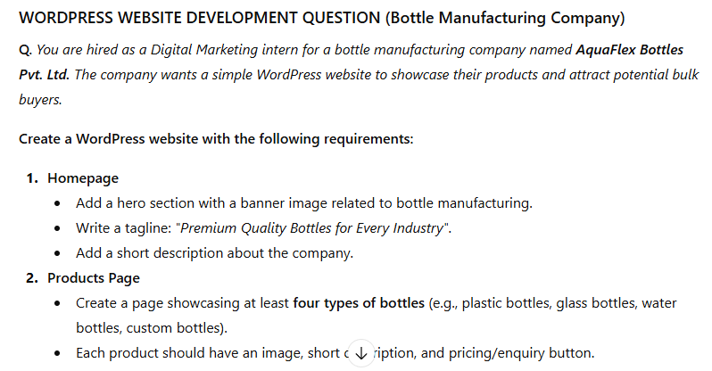
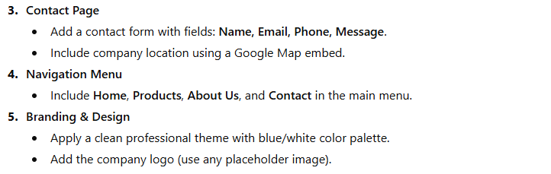

TASK 3 :
Design a logo for a fictional startup in f the following industries:
- Eco-friendly fashion
- Tech innovation
- Organic food products
- Travel & tourism
- Elearning platform
- Sportswear Brand

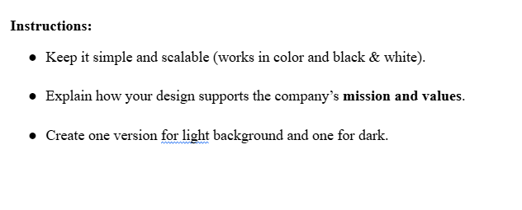
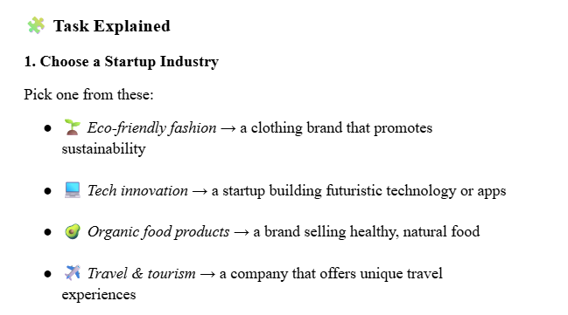
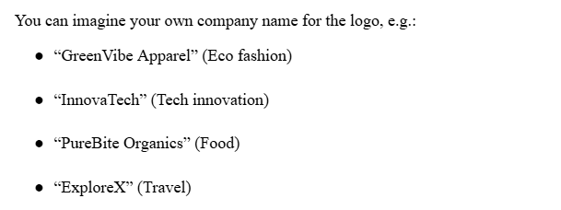
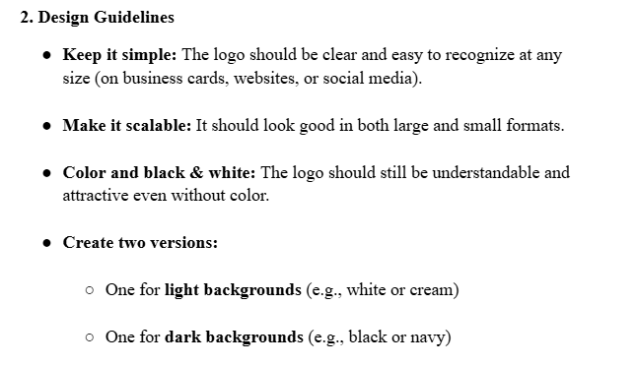
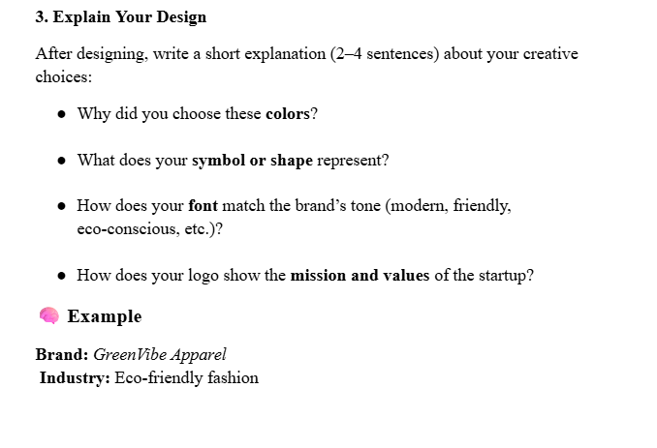

NB: Students, please fill the below details in proper way and upload this word file in to your google drive and share the link in google sheet.
Student Name: | Siddhu Binu
Semester and Branch: | S6 CSE
Email id: | Siddhubinu2@gmail.com
Whether you completed all the assigned task in this week (Yes/No): | YES

- Write a blog post titled: “Top 5 Digital Marketing Trends to Watch in 2025”
(Explain about your tasks and attach the screenshot of your work)

Task Explanation (For Assignment Submission)
As part of the Digital Marketing weekly tasks, I completed Task 1, which required writing a full
blog post titled “Top 5 Digital Marketing Trends to Watch in 2025”.
The objective of this task was to understand modern digital marketing trends, apply SEO
principles, improve content writing skills, and practise creating industry-focused articles.

✔ What I Did in This Task
- I researched the latest digital marketing trends predicted for 2025.
- I wrote a blog between 800–1200 words as instructed.
- I included the SEO keywords:
  - digital marketing trends 2025
  - future of digital marketing
  - marketing strategy for 2025
- I wrote in a professional but simple tone suitable for small business owners and marketing teams.
- I structured the blog with:
  - Introduction
  - 5 main trends as subheadings
  - Bullet points
  - Conclusion with Call to Action (CTA)
- After completing the blog, I formatted it neatly and prepared it for submission.

Top 5 Digital Marketing Trends to Watch in 2025

Digital marketing in 2025 is growing at a pace faster than ever. With even savvier AI tools, shifting expectations among customers, and newer avenues to place ads, businesses need to run at a fast pace to keep up. Whether you're a small business owner, a full-time digital marketer, or part of a marketing team, taking the time to understand the top digital marketing trends in 2025 will help you create a robust marketing strategy in 2025 and enable you to reach the right audience at the right moment in time.

In this blog, we go into detail about the future of digital marketing and go over the five trends that will be most in effect within the industry for the coming year.

1. AI-Driven Personalization To Dominate

AI tools are not new in marketing; however, it's in the year 2025 that personalization becomes hyper-accurate, speedier, and more influential.

What's changing?

Instead of basic personalization like "Hi John", brands will now use advanced AI to analyze:

User behavior

Search patterns

Purchase history

Engagement data on all platforms

This will, in turn, enable businesses to provide ultra-personalized content, product recommendations, and AI-generated ads that cater to the preferences of each customer.

Why it matters

The more customers see content that feels "made for them," the more likely they are to convert. In 2025,

Personalised emails will get higher open rates

Websites will be displaying content depending on users' mood or intention.

This means AI chatbots will work as your virtual sales assistants.

How businesses can make use of this

Use content-generating AI tools like ChatGPT, Jasper, and HubSpot AI

Set up personalized automated email journeys

Track user behaviour through analytics tools, such as GA4

Outcome: more engaged users, increased conversions, and higher levels of trust with customers.

2. Short-Form Video To Become Even Bigger

While short videos have already taken over social media, they will become the prime content format for brand communication in 2025.

Platforms Dominating in 2025

Instagram Reels

YouTube Shorts

TikTok

Facebook Reels

Snapchat Spotlight

For this reason, these platforms are now optimizing their algorithms to push short videos because users love consuming quick, visually engaging content.

Why this trend is important

Short clips:

Increase visibility of the brand

Improve organic reach

Improve audience retention

Allow more engagements.

Best content types for 2025

Demos of products in less than 10 seconds

Customer testimonials

Trend-based videos

Before/after transformations

Tips or educational clips

Tip: Keep videos between 5–15 seconds for maximum reach.

3. Voice Search & AI Assistants Will Drive Traffic

With devices like Alexa, Google Assistant, and AI chatbots on the rise, voice search will play a huge role in SEO in 2025.

What users search for

Voice assistants stand in for people to find:

Local shops

Eating places

Reviews

Services

Information published online

This means marketers have to optimize websites for conversational search queries.

Example

Instead, the user simply says: "best bakery Kochi".

"Where is the best bakery near me that sells fresh cakes?

How to Prepare for Voice Search

Use natural-sounding, conversational language on your site.

Long-tail keywords should be included.

FAQ sections added.

Optimize Google Business Profile

This will particularly help the local businesses attract customers.

4. Real Influencer Marketing Will Take the Place of Traditional Advertisements

Influencer marketing isn't slowing down - it's just changing. In 2025, brands will shift towards:

Micro influencers

(10,000–100,000 followers)

Nano influencers

(1,000–10,000 followers)

These are creators with much more engaged audiences, and they do much more authentic content, as opposed to celebrities.

Why brands prefer micro/nano influencers

Higher engagement rates

Improved trust on the part of followers

Less expensive

More relatable content

Better Return on Investment for small businesses

Influencer Marketing Trends 2025

Long-term collaborations over one-off postings

User-generated content (UGC) campaigns

Influencer-led product launches

Fake followers detection AI tools

Tip: Partner with influencers that align with your brand values, not just the count of followers.

5. Privacy-Centric Marketing Becomes a Must

With growing consciousness on the part of customers about how brands use their data, transparency is now at the top of the agenda.

What's changing in 2025

Third-party cookies are disappearing

Users want transparency in data usage.

Platforms add privacy restrictions.

This means brands must shift to first-party data-meaning data collected directly from customers.

How businesses can adapt

Collect email database from newsletters

Employ signup forms, surveys, and loyalty programs.

Store customer interactions through CRM tools.

Be transparent about why you collect data.

This helps gain more trust from customers and allows business owners to develop better relationships without having to pay any third-party advertisers.

Final Thoughts: The Future of Digital Marketing in 2025

In the fast-paced digital world, only those businesses that will adapt early can lead the race ahead of competitors. Future digital marketing will be driven by AI, short-form video, personalization, influencers, and privacy-focused strategies.

IF YOU ARE PLANNING YOUR MARKETING STRATEGY FOR 2025, THEN FOCUS ON

Creating personalized customer experiences

Investing in video marketing

Optimise for voice search

Using authentic influencer collaborations

User privacy protection

Want More Tips Like This? ????

If you found this blog helpful, subscribe to our newsletter for weekly marketing insights. Need digital marketing services or advice? Feel free to reach out at any time-we are here to help!

2. WORDPRESS WEBSITE DEVELOPMENT QUESTION (Bottle Manufacturing Company)
Q. You are hired as a Digital Marketing intern for a bottle manufacturing company named AquaFlex Bottles Pvt. Ltd. The company wants a simple WordPress website to showcase their products and attract potential bulk buyers.
(Explain about your tasks and attach the screenshot of your work)

As part of the Digital Marketing weekly tasks, I created a simple and professional WordPress website for a bottle manufacturing company named AquaFlex Bottles Pvt. Ltd. The aim was to showcase the company’s products and attract potential bulk buyers. I used the Astra theme and followed all the given requirements.

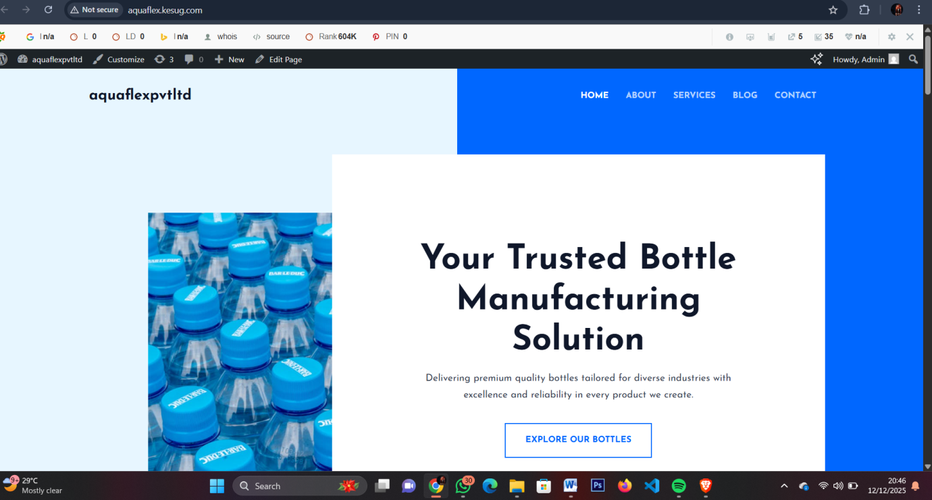

3. Design a logo for a fictional startup in f the following industries:
- Eco-friendly fashion
- Tech innovation
- Organic food products
- Travel & tourism
- Elearning platform
- Sportswear Brand
(Explain about your tasks and attach the screenshot of your work)

Startup Name: FutureLoop

Industry: Tech Innovation

Explanation of the Logo Design Process
For Task 3, I designed two logo variations for a fictional tech innovation startup named
FutureLoop. The objective was to create a modern, futuristic, and professional visual identity that aligns with the theme of technology and innovation.

Explain and attach screenshot

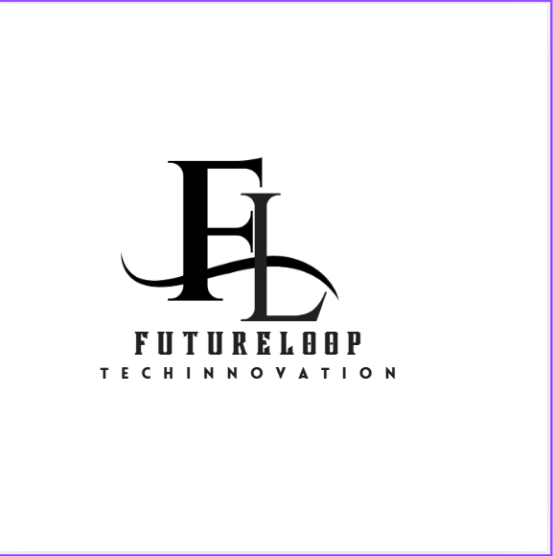

Logo Version 1 – Minimal Black & White (White Background)
This version features a clean, elegant, and simple design using the initials FL, which stand for FutureLoop.
- The typography style is sleek and modern, representing innovation.
- The curved line connecting the letters symbolizes technology, connectivity, and continuous progress, which aligns with the idea of a “loop” or ongoing innovation cycle.
- The black-and-white color scheme gives the logo a premium, professional, and minimalistic appearance, suitable for corporate branding, websites, and official documents.
This version is best for clean branding materials and light-themed backgrounds.

Explain and attach screenshot
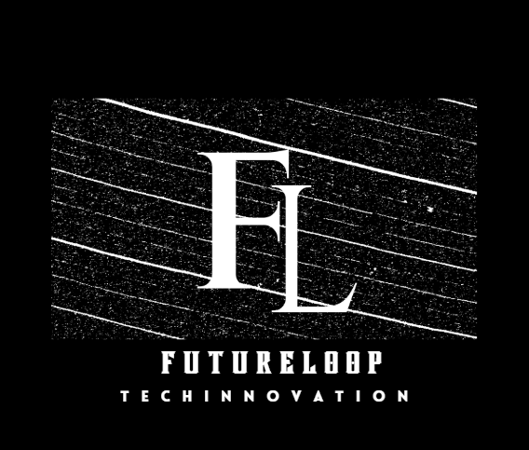

Logo Version 2 – Textured Background (Black Theme)
The second logo uses the same “FL” monogram but is placed on a textured black backdrop.
- This textured pattern gives the logo a modern tech feel, resembling digital waves or data patterns.
- The white text on the black background creates a strong contrast, making the logo bold and eye-catching.
- This version works best for social media posts, banners, tech presentations, or dark-themed brand designs.
Overall, this version represents energy, depth, and futuristic technology, which suits an innovation startup.

